Computer Language Flat & Structured Interchange

Methods & Classes Loosely Coupled
In C++ a method of a class automatically becomes a global method as well. The first argument of the global method, is the object the method is called upon. This is called the this-argument. If the global method has more parameters, that are objects, those objects’ public members are accessible from within the method. Of the this-argument, the global method can also access the private members.

Method not part of class definition
A bold statement, emphasizing total interchangability of global methods and class methods:

Any method that takes an object as an argument, becomes a method of this object’s class.

A parameter adds the method to the class of the parameter.

This makes it so that the very same method can be part of several classes. This makes methods independent entities, that are not tied to a class.

When you add a parameter to a method, the method is automatically also added to the class of that parameter. You don’t even have a say in that anymore. That’s just the way it is.

The principle methods & classes loosely coupled can also be called: procedural and object oriented interchange, because instead of viewing methods as part of classes, you can also view them as a flat list of methods.

You shouldn't see the method as being directly part of the class. The methods just seem to be part of the class. In object oriented programming, methods also just seem part of an object, while they are really only defined inside the class. In Computer Language methods are not even part of a class. They just seem to be part of a class, while they are really independent entities.

When you program a method, that does something, the action is immediately available in the context of any type of object, that has anything to do with that method.

The software development community has been fighting for making methods part of a class, instead than having a flat list of global methods. And here I claim the opposite. Like it is a step back in the development of computer programming. But this system doesn’t pick either side. Methods are both independent entities as well as part of a class. This system makes flat and structured completely interchangable. It is actually the flat part that is physically stored. The structured part is simply derived from that. The structured part is imaginary and volatile. The flat part is fixed and real.

Calling a method on an object
A method can be called on each object, whose class is a parameter of the method.

When you call a method on an object, the object is not visible as part of the parameter list anymore. The other objects still need to be filled in as parameters.

Method’s access to private contents of classes
The this-argument in C++ was special: the method has access to the private contents of the this-argument.

The fact, that you can access the private contents of a methods is a special setting. The fact, that you can access the private contents of a methods is determined inside the class definition, not by the method itself. A class grants a method’s access to its private contents. This makes the method more part of the class, but a method is still a separate entity, that can apply to multiple classes.

Private members of a class are useless, unless there are methods that use these private contents. So the informal connection between classes and the methods, that is established by the class’s granting the method access to its private contents, is very tight, and those methods are actually the protectors of that class’s private contents.

Classes giving methods access to their private contents is formally a form of access control. But informally the methods that have access to the private contents of a class, are the protectors of that class. The class appoints these protectors. Methods do not decide to become such protectors on their own.

Local variables
Local variables, as they are called in contemporary programming languages, are a lot like parameters. Unlike parameters, they are private to the method, rather than publically written or read. Local variables are private contents of a method. Since they can not be publically set, and you can not determine what object the private variable will hold, the method also can not become part of any arbitrary object of the class of the local variable.
So the method does not become part of each object of the class of that local variable, because the object of that local variable can not be freely appointed.

The local variable might make the method part of the class anyway, but then as a static method, that can be called on the class, but not on any arbitrary object.

Methods with fixed logical residence
A class’s granting a method access to its private contents, creates a tight informal bond between the class and the method. The method becomes part of the class in a way, even though a method still is a separate entity. Another way to make a method part of a bigger whole, is to give a method a fixed logical residence. A method already has a fixed physical residence, being the place where the method is stored on disk permanently. A method is stored somewhere, just like an object. But a method can also be given a fixed logical residence. This fixed logical residence shadows the fixed physical residence and gives a method a fixed logical position. The logical residence of the method is the target of all references to the method. Only the fixed logical residence has access to the physical residence of the method.

It is actually advised to give a method a fixed logical residence. Preferrably, you make the method logically part of a module, because modules will bundle together classes and methods to a single logical unit of functionality. Don’t make the method part of a class. This binds a method too much to a class. Give a method the ability to become part of multiple classes, rather than tying it up to a single class. A class’s granting a method access to its private contents already establishes a tighter bond, and the method will be visible as part of the class. You don’t need to give the method a fixed logical residence inside the class to establish this bond.

Automatic containment of methods
Methods can be used in arbitrary places, just like objects. In the article about automatic containment, for objects it is extensively discussed, how that makes objects logically part of multiple wholes. However, a single logical residence of the object was appointed, that is the real residence of the object itself, while all the other locations, were mere references to the object. Also: from the perspective from which you looked at the object structure, a single logical location within view was appointed to represent the object itself, even though the real location of the object was out of sight.

It works the same for methods. A method has a fixed physical location, where the method is physically stored on disk. This physical location is usually shadowed by a fixed logical location, which is the logical target residence of the method. The fixed logical location usually resides directly inside a module. Any pointer to the method directly or indirectly points to the logical target location of the method. However, when the target location of a method is out of sight, a single location is appointed to be the intermediate, imaginary target of the method references.

A reference to a method is either a method invokation, or an inactive pointer to the method. For now only method invokations are considered, also called method calls.

In this story about automatic containment of methods, I will first make methods totally independent entities, not tied to a class at all. I will actually explain here how a more structured view on a method call is translated to a flat view on it, because the flat view is how things will be physically stored. In later sections, I will show, how a flat view will translate to a structured view, and I will explain there how a method’s being part of multiple classes is expressed.

A call to a method contains parameters, to which objects need to be assigned. This is done by tying each parameter to an imaginary reference to the object. The method call will simply contain object references pointing outward to imaginary references.

The method call symbol itself, will point to the closest imaginary reference to the method. The method call symbol will be connected to the closest imaginary reference with a class line (a dashed line), because the method symbols will represent the same class of method, not the same instance of the method (a call is an instance of a method).

The automatic containment of methods has one particular difference with automatic containment of objects. Imaginary references to objects are not show in the diagram, unless the object is actually used in that part of the diagram. Methods are shown in the diagram, even if they are not used in that part of the diagram. Imaginary references to methods are shown inside each object that has a class, that the method uses as one of its parameters. The imaginary references to methods, that are put inside objects, are there, even when they are not used in that part of the diagram. That makes the method available from any object, that could be used by the method. That is a good thing. All methods, that operate on the object are directly available from that object.

Now I will explain, how you create a method call in the programming environment. A method call is created inside another method:

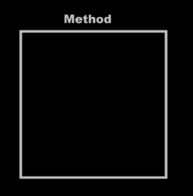 | → | 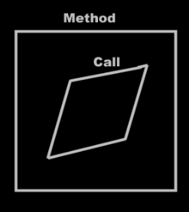
First you create a method call, with no particular method assigned to it yet. Next you tie the method call to a particular method. This method resides usually inside an object. You tie the call to the method inside an object.

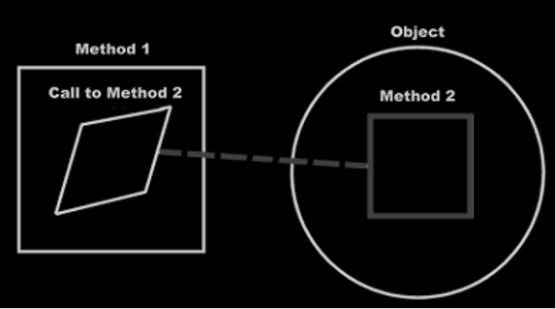

Method 1 now calls method 2 of the object in the diagram. After you’ve done this, the diagram transforms. You, the programmer, tied the call to a method inside an object. The system under the surface ties the method call to the actual method definition, which could be far out of sight.

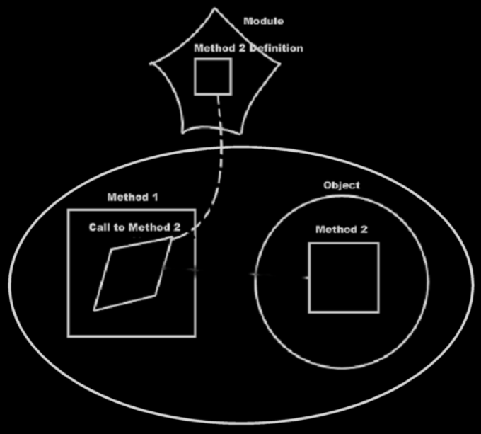

After that, the method call is imaginarily tied to the method definition through imaginary references, that eventually lead to the method definition.

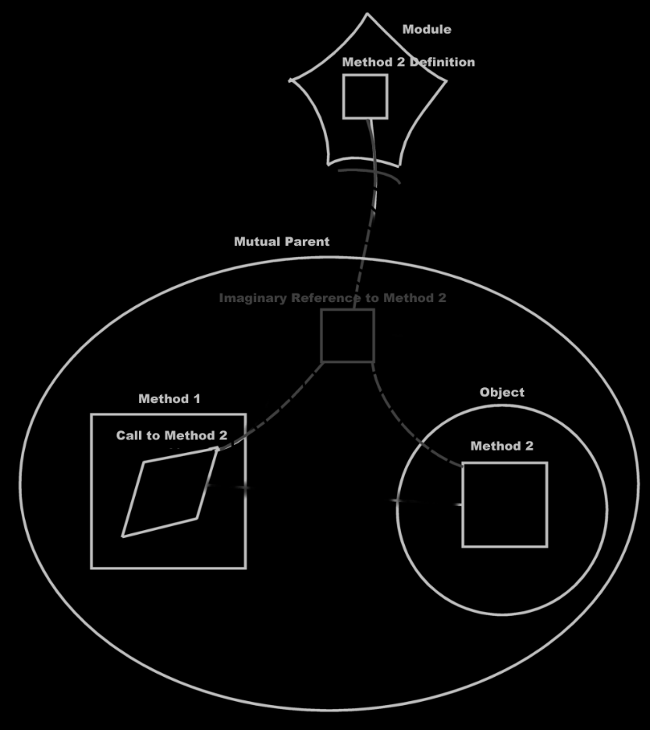

The method call is tied to the imaginary reference to the method, but the imaginary method definition inside the object is also tied to the imaginary reference to the method.

The method call contains pointers to the arguments, which means, that the line, tying the call to a method inside an object:

is now replaced by an object reference inside the call that points to the object.

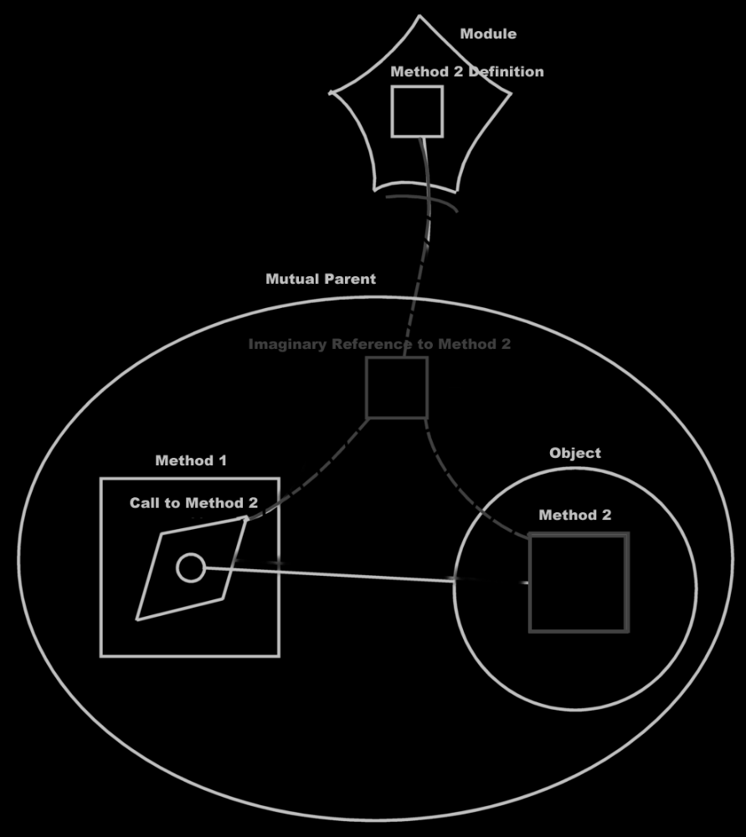

The imaginary method reference inside the object isn’t even pointed to anymore. It just sits there, just as an imaginary reference, that nothing is tied to, just to see what actions you can perform on the object and what you can make the object do. The object simply says: “Hello, this is what you can do to me.” The object methods do point to the method definition through imaginary references, but nothing is pointed to it anymore. After that, the diagram is transformed even more: the parameter might not point to the object symbol you first called upon anymore: it now points to the closest imaginary reference to the object, which may not be the object symbol you used, to establish the call to the object, at all.

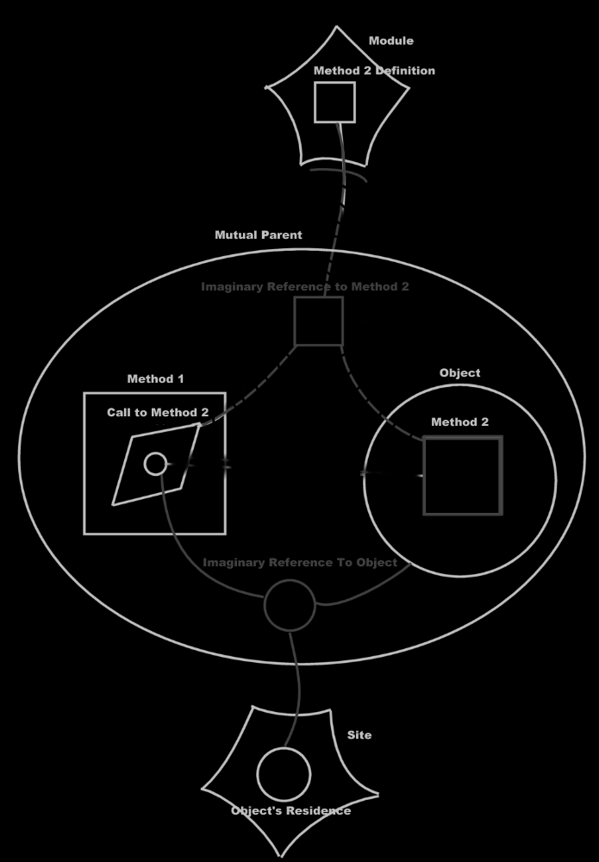

So really, this:

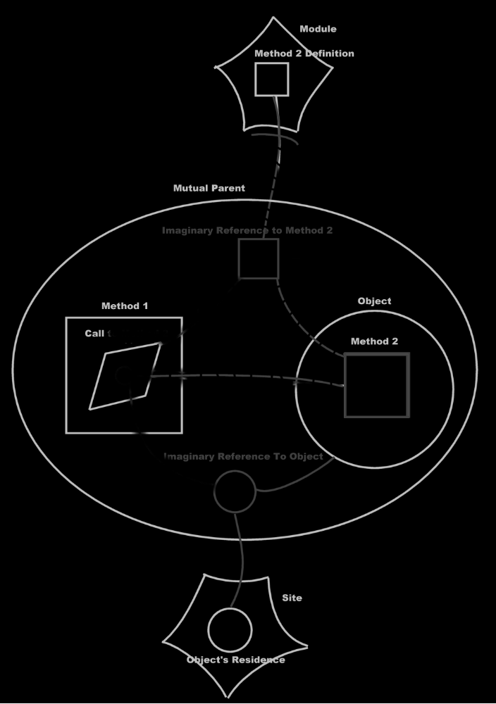

Turns into this:

When you get used to reading the diagrams, you will clearly see that you are calling a method of a module, passing an object on a site to it as a parameter. You also see that nearby there is a reference to the same object, that contains an imaginary reference to the method.

But what you don’t see, is that you are calling a method of an object. That’s what still sucks in this notation.

It’s like the call to an object’s method is replaced by a call to a global method, passing the object as a parameter. But you want it the other way around: you want a call to a global method to be displayed as a call to an object’s method in the clearest possible way. The flat and structured interchange principle methods & classes loosely coupled could have been called automatic class methods too, because global methods should be transformed to class methods automatically.

So it should be the other way around: the last picture should automatically turn into the first picture, and that should be the automatic coupling of the object and the method call.

Expressing a call to a method as a call to multiple objects
The diagrams shown before, is the expression of calling a global method, with its object as a parameter. This turned out to be exactly what I didn’t want to express.

When you have to express that a single method is called upon two objects, you have to tie the method call to both objects' method definitions.

So it would be a call to both objects' method. Instead of referencing both objects from the method, the method is tied to both method references inside the objects.

In this section I display calling a remote method with two remote objects as parameters. And then I display the same call as calling a remote method on both those objects. It’s basically the same example as above, but now with two parameters.

Call to a global method with two parameters:

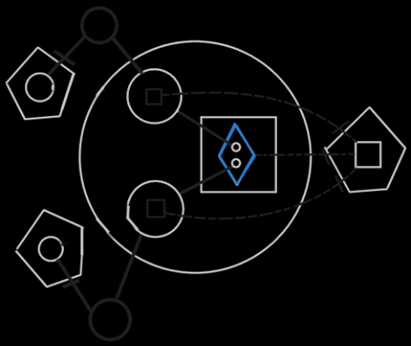

A call upon two objects:

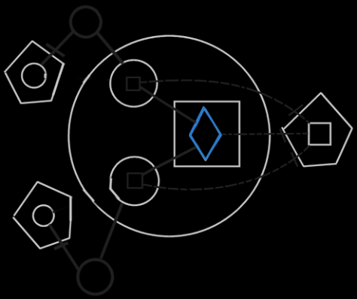

Both pictures express the same physical thing. The first picture displays the objects involved in the method as parameters. The second picture displays the call as a call upon both objects.

This is the best way to express a call to a method, that is part of multiple objects. Looking at the second diagram, you can see that it adequately expresses calling upon multiple objects to execute the same method. It’s a perfect depiction of calling the same method upon multiple objects. This is what exactly displays the interchangability between parameters of a methods and objects whose method is called.

The idea of object oriented is: objects first, procedures second. That’s what the concept explained here establishes.

Editing a call
The objects called upon are displayed as parameter as long as an object isn’t yet assigned to it. As soon as you assign an object to it, the parameter is replaced by a call to the object.

First you create a call inside another method.

Then you need to assign a method definition to it, to determine which method you are going to call, unless you will be defining the procedure right then and there, right inside the call. You can assign a method definition in two ways:

- You point the call to an imaginary method reference somewhere or
- you point the call to an imaginary method definition inside an object.

First the way is where you point the call to an imaginary method reference somewhere.

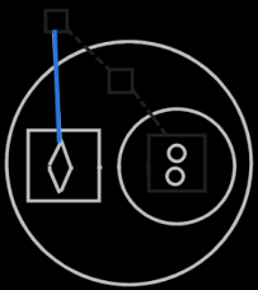

After that, the diagram is transformed, to tie the method to the closest imaginary reference, instead of the arbitrary reference you might have pointed to.

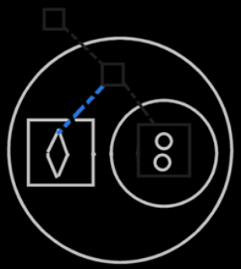

The other way to assign the method definition to a call, is to point the call to an imaginary method definition inside an object.

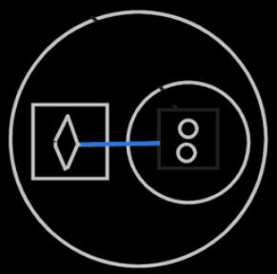

After that, the diagram is transformed to also tie the method call to the closest imaginary reference of the method. But the call is also tied to the closest imaginary reference to the object.
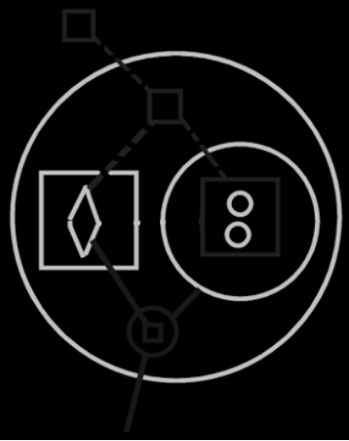

Now that you’ve assigned which method to call, the parameters that are not yet filled in are displayed inside the method call.

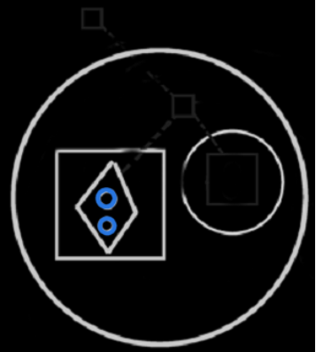

There are two ways to assign a parameter:

- You tie the method call to a method definition inside an object or
- you tie the parameter to an object.

First the way is where you tie the method call to a method definition inside an object.

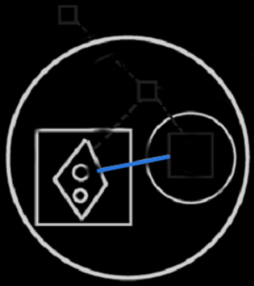

After you picked out the object, the line you drew is replaced by a call to the nearest imaginary reference to the object.

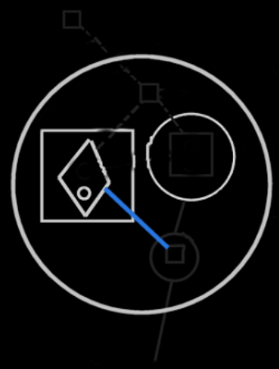

The parameter has now disappeared from the method call, because it is filled in properly and replaced by a call to the object.

The other way to assign an object to the method, is by tying a parameter to an object reference somewhere.

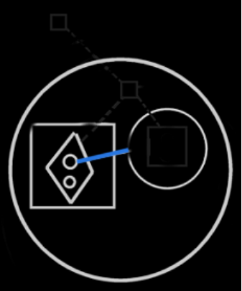

After that, the parameter is replaced by connecting the method call to the imaginary method definition inside the nearest imaginary object reference.

That’s the end result of the other way to assign a parameter.

In the end the parameters are all replaced by calls to imaginary method definitions inside imaginary object references.

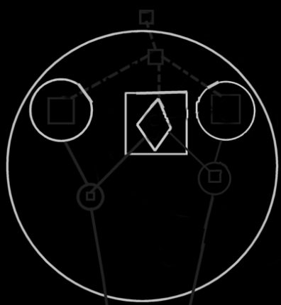

If there are two parameters with the same class, you can’t be sure which parameter is filled in, if you just connect the method call with the imaginary method definition inside an object.

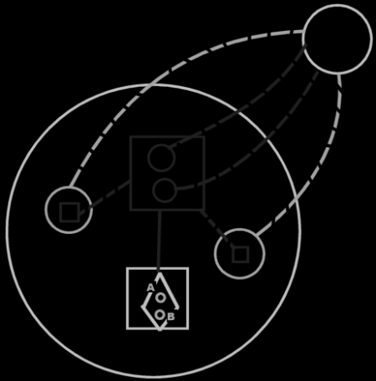

|
\|/
v

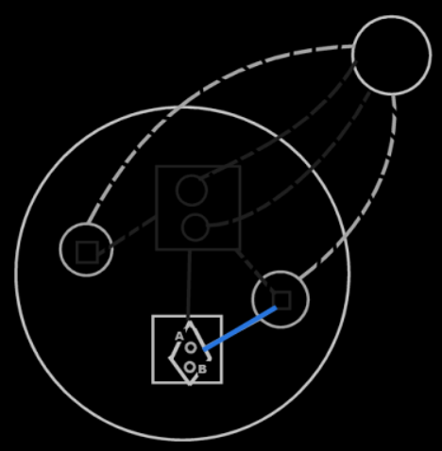

In that case a parameter is not filled in properly yet. As long as a parameter is not properly filled in, it will be shown as a parameter. Both parameters are still shown, until you determine which parameter will be filled in. You can do that by tying the line to a specific parameter.

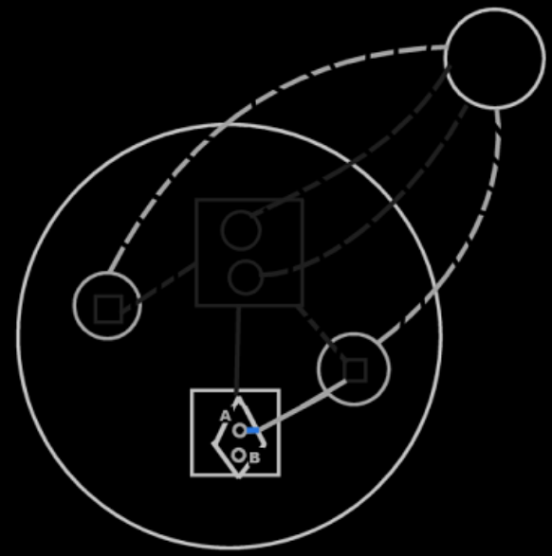

After that, the parameter is replaced by a call to the object’s imaginary method definition again, but now the line is assigned to a specific parameter. The line is now named.

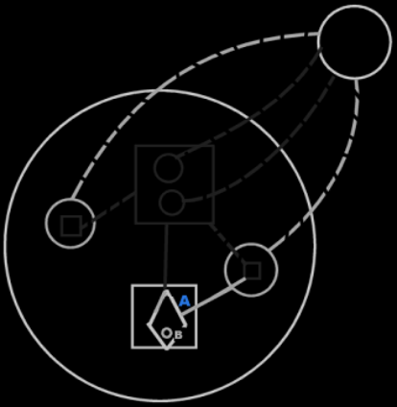

Connecting a parameter directly to a method definition inside an object (the second last picture) might become the implicit notation for interchangability between method parameters and class methods, though, because it may be useful for editing and unambiguity.

Expression of access to privates
In the diagrams above you can see that a call to a method can be a call upon multiple objects to execute that method. It is not yet discussed, how it is expressed that a method has access to the private contents of a class. Access to the private contents of a class creates a tighter bond between a method and a class. This concept is important. However, the expression of it is not important for now. That will be explained in a different article. Its expression in a diagram is does not need to be clarified here, because only the concept of access to privates is important for now. The diagrams in this article are merely for clarafication of the concept and not intended to explain diagram expression itself.

Reliability of class interface
When you use a class, you expect the class to have certain methods; you expect it to have a certain interface. But anyone can add a method to the class now, just by using it as a parameter. If a class gets extended with methods, every time you use it as a parameter, the class’s interface changes all the time. This suggests, that a class’s interface is unstable, and not reliable anymore. The data stored inside a class does not changed suddenly like that, but the set of methods accessible through the class can change all the time. What if somebody deletes his method, while everybody was using it, everybody thought it was part of the class, and then all of a sudden it’s not there anymore, and all the dependencies do not function anymore.

However, interfaces in other systems are just as unreliable as in this system, as I will explain next.

If you use a method through a class, you have to be aware of, what site the method is part of. You have to be aware, that the class and the method may be authored on a totally different sites. You can see in the diagram on what site the method is, compared to the class. In diagrams and in text code, things can be given a different color, depending on what site things are coming from. If the method and the class are from the same site or even the same module, the method may be more dependable, than a method from another site or module. You may be using methods, that don’t have a very reliable source. If you want to use methods from other sites, you’re just going to have to know the sites. If you use a method from a vague site, that didn’t even give the method a fixed logical residence, then the method is not reliable. You have to do with the whole internet now, so you have to be aware of where the stuff you are using comes from. This counts for everything: methods, classes, objects, modules. You just need to be aware what site you are accessing.

A method can only be reliable, really, when the people authoring and using the method have a clear agreement about it. That is no different in other systems. Somebody hosting a web service could very well change the interface of the service, and have software, dependent on that service, crash. The only reason that wouldn’t happen, is because people have an agreement with eachother, not to change the interface just like that. And at times it does change unannounced, it really means systems will have problems.

If you access a method through a class, and that method is hosted elsewhere, you have to know you can trust that other site.

If you want more stability and control over the software you are using, you could always host a copy of a dependency (if you are able to copy it). This is analogus to having a software component installed on one of your own machines, instead of accessing a remotely running software component. Even interfaces of components on your local machine are only stable because of the agreement between you and the producer of the component. If they decided to automatically update the component, the interface or behavior of the component may very well change, and this may cause problems for your software. When it doesn’t, than this is because of the agreement on a human level, that you have with the other party.

That tells you, that a method automatically extending a class, does not make interfaces less dependable than they are today.

Mutual methods, mutual interfaces

A method is an interface
If multiple classes can support the same method, then the classes support the same interface: an interface that has only one method. The interface is represented by the method itself. Each method implicitly creates an interface. That is how it is expressed in a diagram too: a method implicity creates an interface.

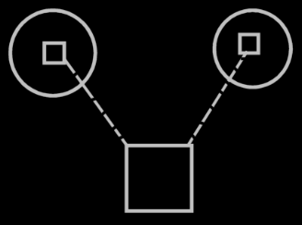

You don’t see a triangle around the method, that would specify, that it is a separate interface: each method automatically becomes a separate interface. Just like each object also defines an interface; even though there is no triangle directly inside it, it still has an interface.

Multiple classes can support the same method
As you could see in the previous section: multiple classes, that support the same method, also support the same interface. Multiple classes supporting the same methods logically seems to create overlap in interface, but it doesn’t look like overlap in the diagram.

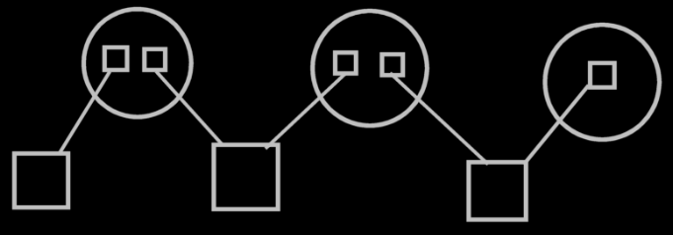

There are just multiple imaginary interface definitions, that each reference a different set of methods.
So a class referencing multiple methods, referenced by multiple classes, creates a visible interfaces of the class. The visible display of this interface is there when you display the methods as part of a class, and not when you display the classes as parameters of the methods.

Method extending a class from another system
If two different sites define methods for the same class, this creates two interfaces for the class. If more methods for that class are defined on another site, this creates another interface for that class. This groups the methods of a class by source. That makes it so, that classes can be extended with methods very easily and suddenly, but interfaces don’t change that suddenly. Interfaces are author-bound, so one clumsy author can not mess up an interface authored by the one that authored the class himself. With methods coming from another site, it looks like the class has several method interfaces: one for each site.

Or perhaps less specifically: each object, that defines methods for the same class, creates a separate interface for that class. Defining a method, means the method has a fixed logical residence inside that object.

Class data & class methods target definitions
The logical target class only defines data, not methods.
The data and the methods are defined in an imaginary target class. This imaginary target class is defined on a higher level than the logical target class. The class’s imaginary definition resides on a level, that’s above all the sites that define methods for the class.

The logical target class only defines data because methods are too freely definable. Other methods can be way out of sight, on a totally different site, that the class isn’t even aware of. Consider that an object in real life is defined in shape and form, but you can always invent a different use for the object: the object itself doesn’t need to change for that.

The residence of the imaginary class definition depends on the level of detail that you see in the diagram.

The target definitions of methods, as opposed to target classes, have separate target definitions, separate from the class definitions, and the target definition of class methods only indirectly refer to target definitions of methods. The picture below visualizes the concept of class data and class methods target definitions.

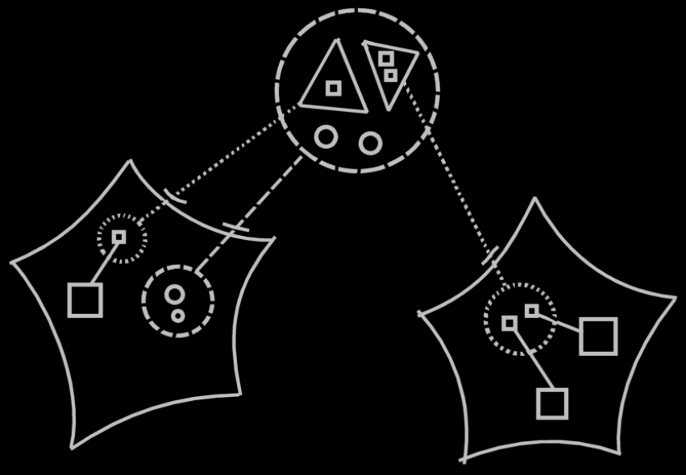

The large dashed circle at the top of the picture represents the imaginary target class, which contains both data (the little circles) and method interfaces (the triangles). The data is part of the actual class, which contains only data. The logical target of this class resides in the site on the left and is represented by a dashed circle, to which the imaginary target class points with a class line. The two method interfaces inside the imaginary class definition at the top of the diagram each point to another site’s method interface. Finally, the target method interface definitions on the sites, each contain references to methods defined on that site.

The notation above is a clear display of what is going on, but it may not conform to the eventual rules of notation of the diagrams. A discussion about the diagram notation is beyond the scope of this article. The diagram is only intended to clarify the concept.

In the diagram above you can see, that the method interface in the second site, is part of a class on the first site. But what if you zoom in on the second site:

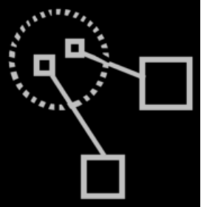

You no longer see the class itself on that level. You need to express somehow, for what class the method interface is defined. The solution is to have an imaginary reference to the class in view. If you define method for a class somewhere, then an imaginary reference to the class needs to be there:

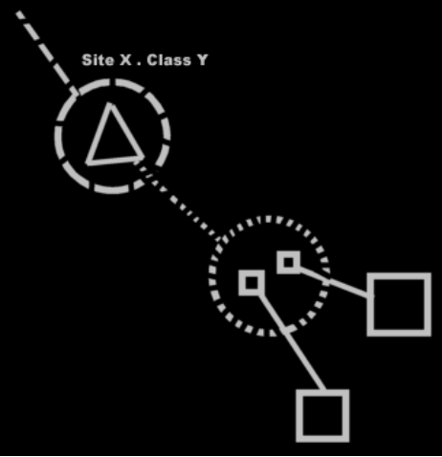

Now an imaginary reference to the class is there in the diagram, the logical target of which is specified by its name (Site X . Class Y), and it is pointing out of the diagram to indicate the target is out of sight.

Objects contain all available methods
Any object of a class contains all data and all available methods. How all the methods can be gathered up is still to be solved: you can’t scan the globe for methods. Actually, any imaginary class definition could also get all data and all available methods, since you also want to see anything available through a class.

Method definition accessing the objects
If you are authoring a method, you need to be able to access the object, the method is called upon. When you display the objects as parameters of the method, you can easily use the objects in the method.

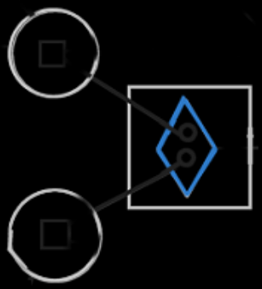

But parameters get replaced by imaginary method definitions inside the classes:

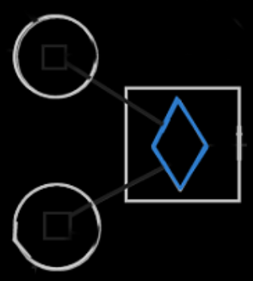

This is because this gives a more intuative view on the process. But then, the references to the objects aren’t directly accessible from within the method definition.

The solution is to show the objects inside the method anyway.

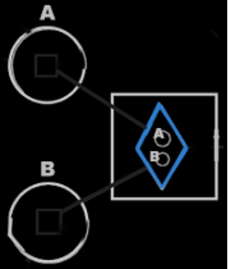

A call upon two objects makes the two object available inside the implementation of the methods. The object symbols of the parameters are sort of like extra imaginary references to the objects.

You don’t need to connect the two references to object A to eachother. They are already implicitly connected by the line between the call and the method definitions.
However, the parameters will not have the same name as the objects, so you might going to have to connect the objects and the parameters together somehow. I’d rather go for the following implicit notation in that case:

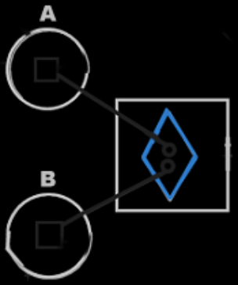

That notation does express interchange in a way, so it may be ok.

In object oriented all members of the class, that the method is part of, were available directly, without qualifying them with the object name, in other words: without accessing them through an object. But in methods and classes loosely coupled, the object a method is called upon is like accessing an object from inside the method anyway. But perhaps this notation will be changed in the future.

Methods in class reuse with inheritance
It used to be an issue if inheritance would still be reliable, when a class’s set of methods can so easily change. The issue was: how does the ‘unreliability’ of a class’s composition affect inheritance? But now we’ve seen, that the total set of methods of a class may change volatilily, but a specific interface of a class does not change that volatilily. Each site specifies a separate interface of methods for the class, and these interfaces are as reliable as the site itself, and don’t change that suddenly.

The thing is: you shouldn’t really see the methods as part of the class. Only the data is part of the class. Methods are only imaginarily part of the class. In inheritance the data is inherited from the base class. Also, in inheritance every method available from the base class will be available in the derived class. If interfaces or methods from the base class change or get deleted, they also get deleted from the derived class. The interfaces are just as ‘unreliable’ in the derived classes as they are in the base classes. But they’re not that unreliable, as we’ve seen. A class can easily get more interfaces, but an existing interfaces are as reliable as the site the interface is defined on.

Methods in reuse of interfaces
It also used to be an issue, whether the reuse of interfaces would still be reliable, when a class’s set of methods can change so easily. Every object symbol was able to serve as an interface, so when an object’s set of methods can change so suddenly, what good is it to use the object as a definition, that defines the expected interface.

The full method interface of a class may be unreliable, but a specific method interface of a class is not. You will be more likely to reuse a specific method interface of a class, rather than to borrow the whole method interface of a class as an interface.

Extensive classification with interfaces
A method implicitly creates an interface: an interface that has only one method. When methods for a class are implemented on a site, this also creates an interface for the class. These interfaces are defined automatically. Methods & classes loosely coupled creates interfaces, that already have an implementation. You are not borrowing an interface from elsewhere, and then giving it a new implementation.

Methods & classes loosely coupled leads to the idea of automatic definition of interfaces. Manually defined interfaces also still exist. Rules for extensive classification through interfaces will be discussed in the article Extensive classification through interfaces. Extensive classification through interfaces is about automatic definition of interfaces, as well as manual definition of interfaces. There may be more automatic definitions of interfaces, than just the one concerned with methods & classes loosesly coupled, but this will be discussed in Extensive classification through interfaces.

Perhaps there will be other ways interfaces will be automatically defined, but that’s not important for now. For now it is important to understand, that method parameters are interchangable with class methods,
that multiple classes can support the same method,
and that mutuality of methods creates mutuality of interfaces,
and that different sources of methods are seen as different interfaces for a class, which makes interface of a class reliable, even though the full amount of methods of the class is very variable.

Author & Copyright: Jan-Joost van Zon Date: April 27, 2008 – May 17, 2008 Location: Oosterhout, The Netherlands Status: Far done

Ideas

Interfaces, unused material
- Unused phrases:
You can refer to a class using an interface.
- These interfaces also define their implementation
Interfaces don’t have to define an implementation. But mutuality of methods, does not only create mutuality of interface, but also mutuality of the implementation of that interface. It gives classes a mutual definition of a method.

<

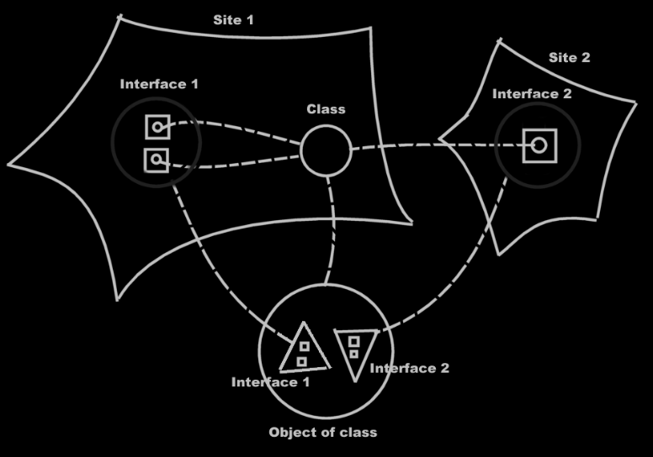
< You may want to not embed the method definitions directly inside an interface, because this suggests the methods are embedded into an object. You may create a new imaginary object symbol for every interface that is created.
Looking at it like that, you can easily see that a class has several interfaces with an implementation directly tied to it, but the interface is defined elsewhere, and an interface is definable elsewhere.

>

<Brainstorm Items>
<
Remember: any piece of data used by a method is a parameter of the method.
If a sub object of a parameter is used, this data is considered a parameter itself, because it gets read or is affected.
The usage of the data is analysable in the new computer language, and the usage of the data is important, and determines the data’s position in relation to the method.
>

< What if a method has two parameters, but both the parameters have the same class? You may need to see it as a method static to the class.>

< How does a class get an imaginary reference to each of the methods, that use it? You can’t scan the globe for all methods that hold that class. I don’t know how to solve that yet. >

<
To consider:
- Method references as opposed to method calls.
>

< The view the other way around, multiple methods can support the same class, is not that important, because that is the parameter point of view, and the class method point of view is preferred over that. >

Parameter & Class Member Interchange
Any class used directly inside a method, must become a parameter of the method. The method becomes part of any class used by the method.

< wrong >
Certain classes may not be further extended.
This may be in the way of this flat & structured interchange.
You might create a derived class in that case, if the original class can not be extended with methods.
But… a class doesn’t have any methods anymore.
< / wrong >

You also don't want the class Integer to be extended with
any method that uses integers.
Actually, the method will only become part of the classes that it directly uses. When the method uses submembers of the classes, the method does not become part of the classes of the submembers.

This needs to be further thought through.
You can however stop a parameter from creating an extra member in its class, but by default the class gets extended.

<~>The globality<~> can get a lot of overloaded method names, but this was already the case in languages such as C++. All the methods of all classes were already reachable globally.

The method’s name is the same in all classes. But methods can be overloaded. They can even be overloaded having the same signatures, because in the diagram they are different symbols, and can be reached separately regardless of their name.

In text code this will look like a method being reachable through any object that has a class that is a parameter of the method.

<> Perhaps the way the object is used by the method, creates a stereotype, analogus to our human language grammar. Onderwerp, leidend voorwerp, meewerkend voorwerp en allerlei bijwoordelijke bepalingen, might be determined by the fact if a parameter is read, written, read and written, only transferred to other methods, state written, state read, member written, member read… <>

In diagrams this will look like: when you create a method within a class, the neareast globality gets a method too. A class line is drawn between the global method and the class method. When you add a parameter to the method, the class of the parameter also gets the method. That basically places the object (the parameter) inside the method and automatically places the new method inside the object. If you assign a class to the parameter. The class gets the new method. The methods are all class-tied to the global method.

Perhaps it would also work like this: automatic containment is applied to the method. When a method uses a certain class, the method is ~ placed inside at the topmost container… how did that work again? So the method doesn’t become global… huh? How did automatic containment work again?
So the method does not become global, but it becomes part of the biggest whole.

A problem here, is that the interface of a class can change very suddenly. When you define a method, and simply give the method a parameter of a class, the class gets extended straight away.
That may cause of problem, when it is important a class has a certain interface. I’m not sure how that will be solved, yet.

The data interface of the class doesn’t change that suddenly.
The method interface does. I guess, if you use an interface it is only for a couple of possible purposes:
(I’m not sure this list is complete)
- Support a sure set of members
- Participate in existing systems
- Derived from another class
If you want to support an interface something else has defined, you will support all its methods, through that interface. But what if that something else’s interface changes too? Then it does. You don’t expect a program to all of a sudden change, so the interface should be staying the same.

What if another system uses a class as a parameter? Will that extend the class defined elsewhere? No, a class defined elsewhere is probably protected agains class extension with methods. But within your own system the external class could become a derived class that does have extended methods.

There should be mechanisms that limit class extension with methods that have the parameter as the class. Access control should be that mechanism. Access control is also the mechanism, that limits change of containment structure. Yeah, access control is the key.

-----

When you can't change a class's definition,
should a derived class be automatically created,
in order for the method to be added to the class?

> So even, when a class is inside another globality,
and you create a method, that uses that class,
the class SEEMS to get extended, but only when the method is accessible.
Huh?

MCLC,

Je moet gewoon net zoals bij AC eerst het hoofdidee uitwerken, en daarbij alle dingen, die het moeilijker maken negeren en bewaren voor later.

Dan zie je dat wel weer terug in de uitleg, net zoals bij AC, dat ik een beetje op dingen terug moet komen. Ik weet niet of dat bij MCLC ook weer gebeurt. Maar is dat eigenlijk zo slecht? Als ik het mezelf op die manier moet uitleggen, is dat dan ook niet de beste uitleg naar anderen toe?

JJ

< Make it extra clear, that displaying a method as part of a class is very very preferred over displaying the class as a parameter of a method. >

